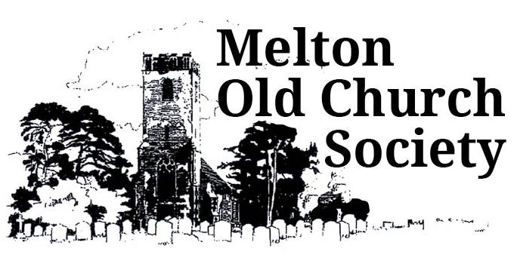
Membership
Membership of the Melton Old Church Society costs £10 per person or £15 per couple. If you wish to become a member, please complete the form below and send it together with your subscription to the Treasurer:
Chrissie Barkes, Decoy House, Old Church Road, Melton, IP13 6DH
E-mail: chrissiebarkes@gmail.com
Enquiries: Chrissie Barkes
Phone: 07714772375
Cheques should be made payable to Melton Old Church Society
Name:……………………………………………………………………………….

E-mail:………………………………………………………………………………

Phone:………………………………………………………………………………

Address:…………………………………………………………………………..

……………………………………………………………………………………….

……………………………………………………………………………………….

If you would like to help with events, open days etc by serving teas or baking a cake, please tick the box below:
☐ I would like to help serve teas/provide cakes or savouries

